SAPB1 Add-On DOCUMENT

(Bin Location Auto Select [FIFO])





By:

AXXIS CONSULTING

Sep 2021

Contents

Document Approval 4

Document Versions 5

As Per Nissei ASB Requested 6

1. Addon – Auto Selection of Bin Location from the earliest received stock Quantity 6

1.1. Current SAPB1 - Bin Location 6

1.2. Addon Details 6

1.3. Installation - Database 6

1.4. Assumption 6

1.5. Reason for Add-on: 7

2. Addon – Bin Location Showing on the Main Page Content Row 7

2.1. Current SAPB1 Standard - Bin Location no showing on Main Page (Current) 7

2.2. Installation - Database 8

2.3. Addon Details 8

2.4. Assumption 8

**Confidentiality Statement**

The content of this document shall remain the confidential property of **AXXIS CONSULTING (S) PTE. LTD.** and may not be communicated to any other party without prior written approval of **AXXIS CONSULTING (S) PTE. LTD.** This document must not be reproduced in whole or in part. It must not be used other than for information purposes only by **AURUM MESTIKA SEJATI PTE. LTD.** except with the prior written consent **of AXXIS CONSULTING (S) PTE. LTD.** and then only on condition that **AXXIS CONSULTING (S) PTE. LTD.** and any other copyright notices are included in such reproduction. No information as to the contents or subject matter of this documentation or any part shall be given or communicated in any manner whatsoever to any third party without the prior written consent of **AXXIS CONSULTING (S) PTE. LTD.**

Any services to be provided by **AXXIS CONSULTING (S) PTE. LTD.** as proposed in this document shall be subject to the standard terms and conditions of **AXXIS CONSULTING (S) PTE. LTD.** for the provision of the relevant services.

# Document Approval

|  |  |
| --- | --- |
| **Nissei ASB Pte Ltd (NISSEI)** | **Axxis Consulting Pte Ltd** |
| **General Manager**  Karen Koh  **Key Process Owners**  Janice Wong | **Marilyn Ganzon**  Project Manager  A picture containing shape, arrow  Description automatically generated  Functional Consultant  Feiyaz Chan |

**Change Request Form**

Number: **NASB001.00**

Date: 13 August 2021

Prepared By : Feiyaz Chan

Below Signed CRF:

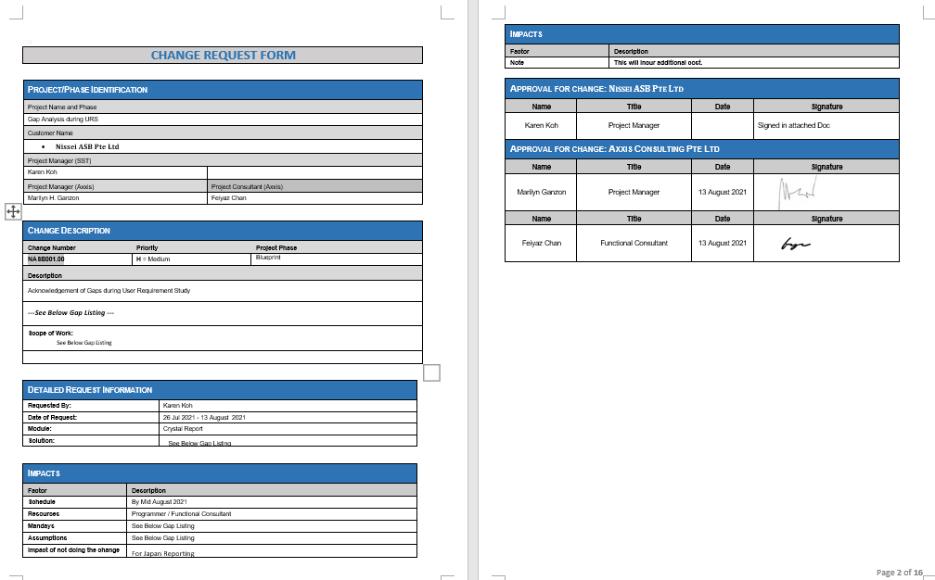

# As Per Nissei ASB Requested

When import data, SAP B1 help to choose BIN location by FIFO and show in main page automatically.

# Addon – Auto Selection of Bin Location from the earliest received stock Quantity

## Current SAPB1 - Bin Location

In standard SAPB1, User must manually click on the Bin Location Box “Choose from List” icon and choose the Bin Location Manually and then return to main screen

*Below Shown : 2nd window pops out for user to choose Bin Loc Manually -*

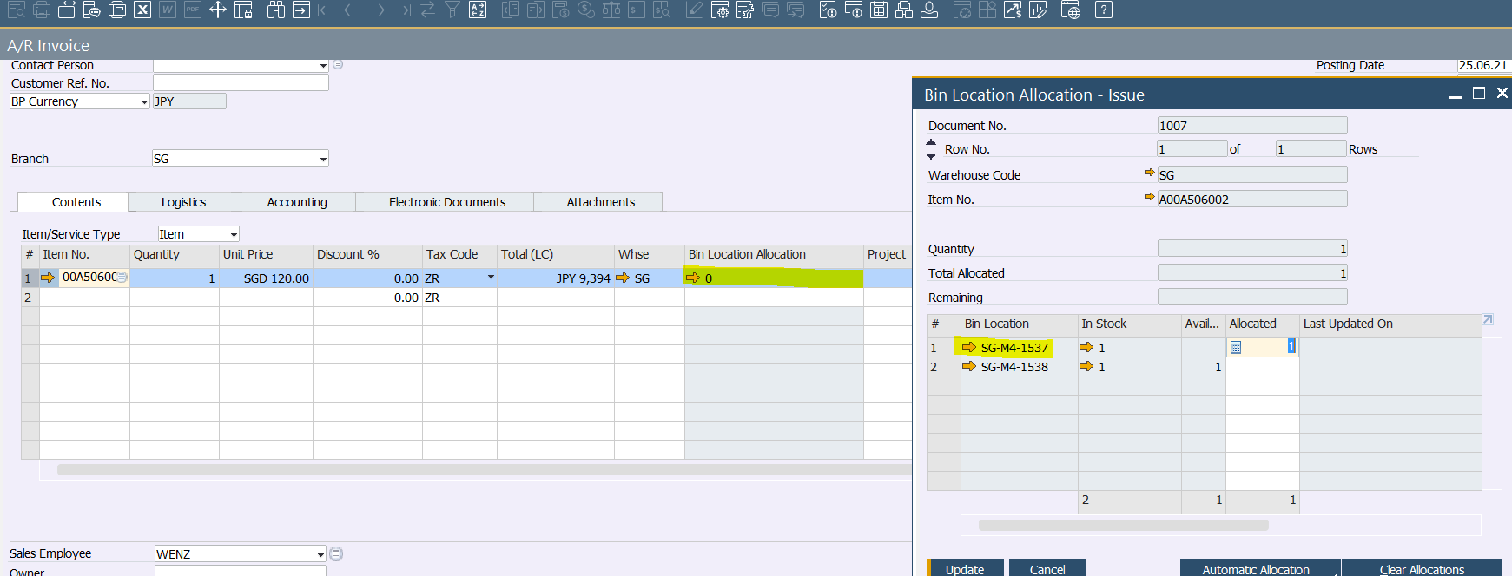

## Addon Details

Auto Selection of Bin Location based on the earliest Received Quantity, user do not have to click on the ‘Bin Allocation Window’

Addon will be appeared on SAPB1 Screen

* Delivery Order (Item Issue for Delivery from Bin Location WH)

Upon Selection of Bin Location

## Installation - Database

This Addon will be installed on Nissei ASB Pte. Ltd.

DB Name - ASB_SG_LIVE

## Assumption

* **Goods return to Supplier** from Bin Location WH)

User will need to Select Manually because these returns may not be the earliest received Stock

* This Addon will not be handled in **AR Invoice and Stock Issue** Screen

Should there be such transactions

* + - AR Invoice – Users have to create Delivery Order then copy to AR Invoice
    - Stock Issue – Users will have to select Bin Location Manually
* User will not choose more than 1 Bin in one row,

Should there be more than 1 Bin Location, user must split into 2 rows

* One user performs at one time, no multiple users doing the AR Invoice at the same time

## Reason for Add-on:

Users want to reduce the steps of clicking to Box for Bin location and choosing manually for the bin location.

Extra Steps, user find it troublesome

# Addon – Bin Location Showing on the Main Page Content Row

## Current SAPB1 Standard - Bin Location no showing on Main Page (Current)

In Standard SAPB1, the Bin location column is showing the quantity has been allocated

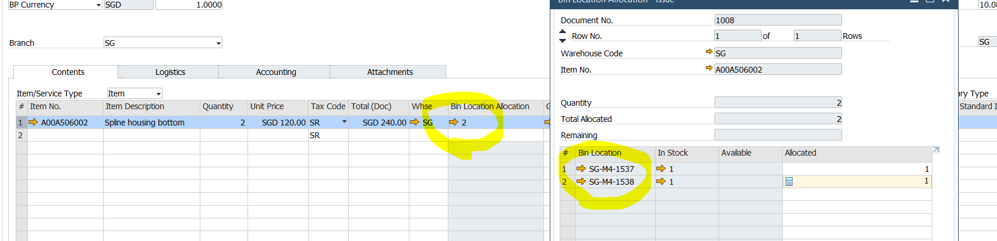

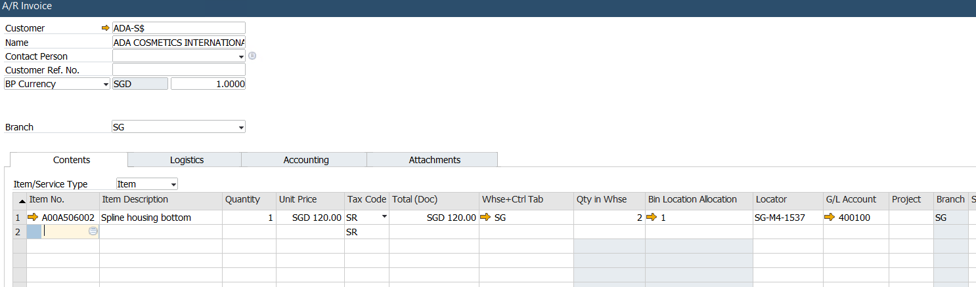

After User Choose the Bin Location in the 2nd Window, the Bin Location is not showing on the main page instead user must click on “Bin Location Allocation - Issue” Window to view details of Bin Location Number

## Installation - Database

This Addon will be installed on Nissei ASB Pte. Ltd.

## Addon Details

Chosen bin Location Number to be shown on Main Page to be shown on the main page

Addon will be appeared on SAPB1 Module

* Delivery Order (Add-on auto select Bin Location)
* Stock Issue Screen (user manual select Bin location)
* Goods Return to Supplier Screen (User Manual select Bin Location)

## Assumption

* **Goods return to Supplier** from Bin Location WH)

User will need to Select Manually because these returns may not be the earliest received Stock

Bin Location Information will appear on the main screen after user select manually

* Bin Location will be shown in AR Invoice but the Bin Location need to be selected in Delivery order
* User will not choose more than 1 Bin in one row,

Should there be more than 1 Bin Location, user must split into 2 rows

* One user performs at one time, no multiple users doing the AR Invoice at the same time